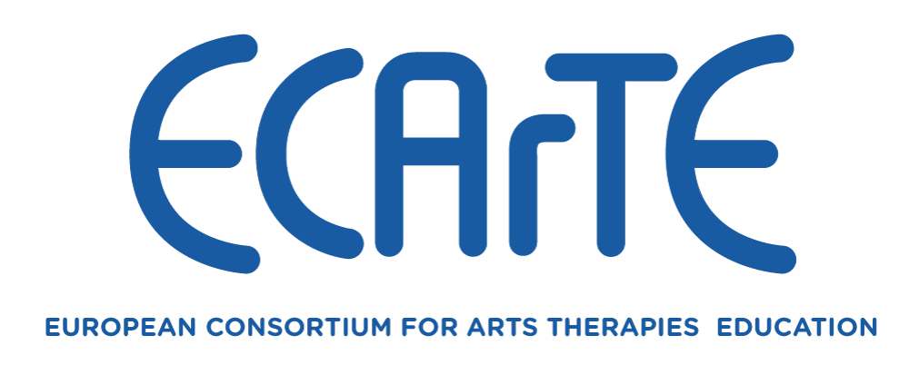

**State of the Arts Therapies Training in Europe (SATTIE) Research Project, Phase 2**

**Calls for Expression of Interest to participate in Nominal Focus Groups**

The SATTIE research team would like to recruit participants from ECArTE member states as well as from the wider allied mental health professions to participate in a set of nominal focus groups. The aim is to help ECArTE establish indicators of good practice in Arts Therapies Education in Europe for the 21st Century (*please see the accompanying Information Sheet for details*).

If you are interested in participating in one of the nominal focus groups, please provide the following information:

**Name:**

**Arts Therapy Discipline or Interest:**

**ECArTE member state:**

**Professional title:**

Please return your replies by email to Dr. Daniel Stolfi at [dstolfi1@gmail.com](mailto:dstolfi1@gmail.com) by Friday, 11th February at the latest.

Many thanks for your interest.

*From the research team: Daniel Stolfi, Marian Cao and Richard Hougham*